Web Work Request Policy
8/28/2001
Revised 6/24/02

Please observe the following policy guidelines when requesting any type of web development.

- Requests must come from only Project Managers/Team Leads
- Requests are not to be taken to a web developer.
- ALL requests will go through SCG editing reviews before made available to the client, unless noted otherwise.
- ALL documents shall have reviewed by Editing (and corrected) prior to submitting to TEAM Web. The yellow editing sheet should be attached to the Work Request.
- Work Requests are a completed unit of work. If you need to correct/append/delete something outside your original request, submit another Work Request and detail your needs.
- All email correspondence regarding your request will contain the Tracking Number somewhere in the subject line.
- Requests should be submitted prior to 3PM. Requests made after this time will be scheduled (if possible) for the next business day.
- Work will NOT be published without a PM or TL signoff!

FOR PRINTED HARD COPIES
- Printed copy is no longer being accepted, except for use as a guideline for layout.
- Please see DIGITIAL AND ELECTRONIC for instructions.

FOR DIGITAL AND ELECTRONIC COPIES
- Use your internet browser to access http://webdev-scg/ - select the link for Work Requests
- Complete the form – fill in all fields
- Submit the form (press the submit button). You will receive an email with the information, including the Tracking Number.
- Print out the completed work request form
- Reply to the email you just received, and attach the document(s) to the email or use the Document Upload .
- Place work request in top of tray on my desk

HOW IT WORKS
- Request received
- Reviewed and queued for priority and scheduling
- Assigned to a developer
- Work completed
- Webmaster provides a cursory review to ensure document structure and code are in compliance with guidelines. Initials required for proceeding to next step.
- Submitted to Editing for their review (if required).
- Updates as recommended from Editing, if any, are made. Editing signs off on work request. Initials required for proceeding to next step.
- Submitted to Project Manager for ensuring work-performed matches work requested.
- Work is re-done and resubmitted to PM until a signature is obtained, if rejected from step 7. Initials required for publication to live production server.
- Webmaster reviews final product. Approves publication to live location
- Work Request closed.

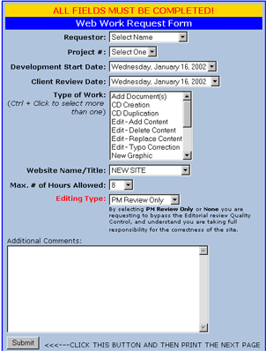
Required. Select your name.
Required. Select your project. It is CRITICAL that you select the correct project number here.
Required. Select dates you would like to begin work on this and when you would like the client to review. Please be as liberal as possible. For complex tasks, you may consult with Mark for an idea of time required.
Required. Select all applicable options as needed to describe this request. If you don’t think an option fits your needs, then select “ADD DOCUMENT”.
Required. Select your site from the list. This defaults to NEW SITE. Your site is listed unless it is a new site.
Required. How many hours will be needed to complete the task? This does not include hours for editing.
Optional. Place specific instructions here.
Required. Select the edit type you need to have performed. Refer to the back of the yellow edit sheets for detailed information on each level of edit.

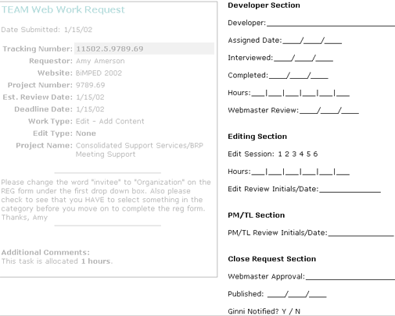

The assigned developer initials
Used only if the developer needs to “interview” the requestor for more details or clarifications
The date the work was initially completed prior to editing and reviews
Mark’s cursory review for structure, page layout and design. Content edits and reviews not made at this stage. Validates OK to proceed to EDIT process.
Iterative process for editing. Indicates how many times this task went thru editing. Hours are provided as a courtesy to the PM for tracking.
Editing’s signoff that the content for the task meets SCG standards. If this is a “PM Review Only” or “None” edit type, then the PM must initial here with date.
Project Manager’s or Task Leader’s initials indicating the Task is ready for publication for client use. No work will be published outside the developer section without initials.
Final release authorization for client access and indicates this request is closed. Indicates date accessible by client

STEP 1

STEP 2*
STEP 3
STEP 4
Each step requires an initial in order to proceed to the next step.

Do not remove attachments or print outs between steps.

ALL documents and attachments must stay with the request throughout the task life cycle.
* = Step 2 is optional.
This applies only if the EDIT TYPE is not PM Only or NONE. PM’s should initial here if so desired to indicate they are assuming responsibility.

